Shell scripting

program-1

Aim:Write a shell script to print the basic details.

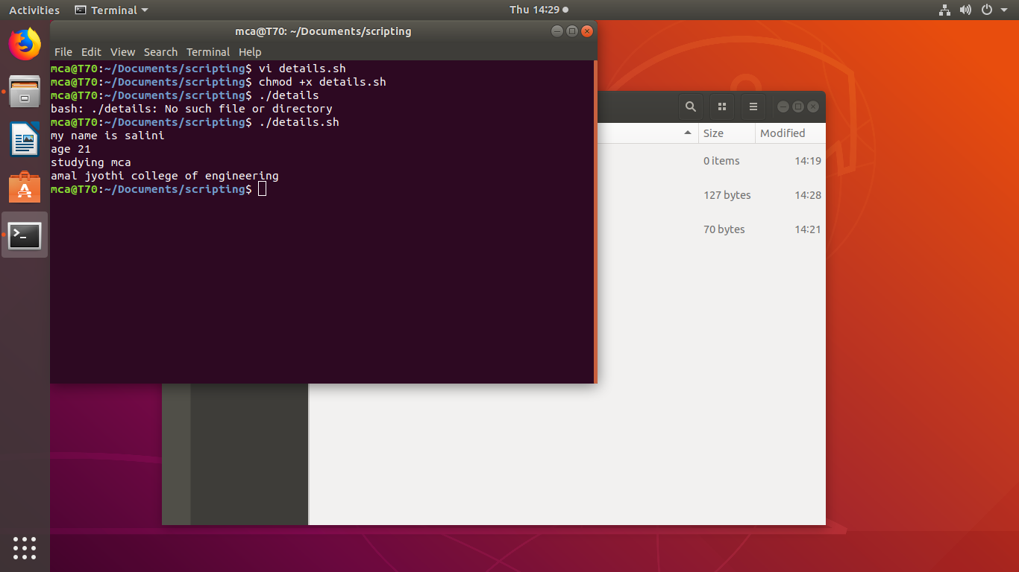
Program no-2

Aim:sum of two numbers.

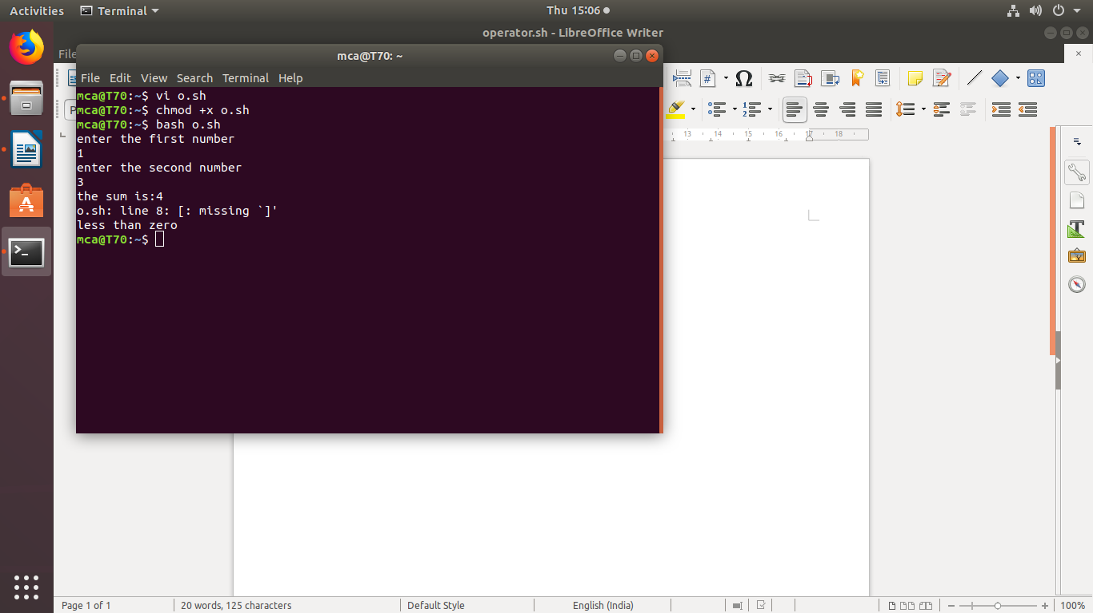
Program no3
Aim:largest of two numbers

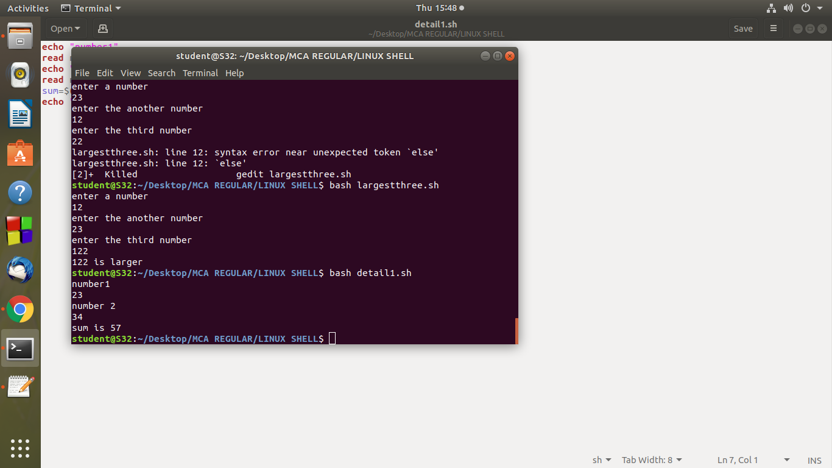

Program no4:
Aim:largest of 3 numbers

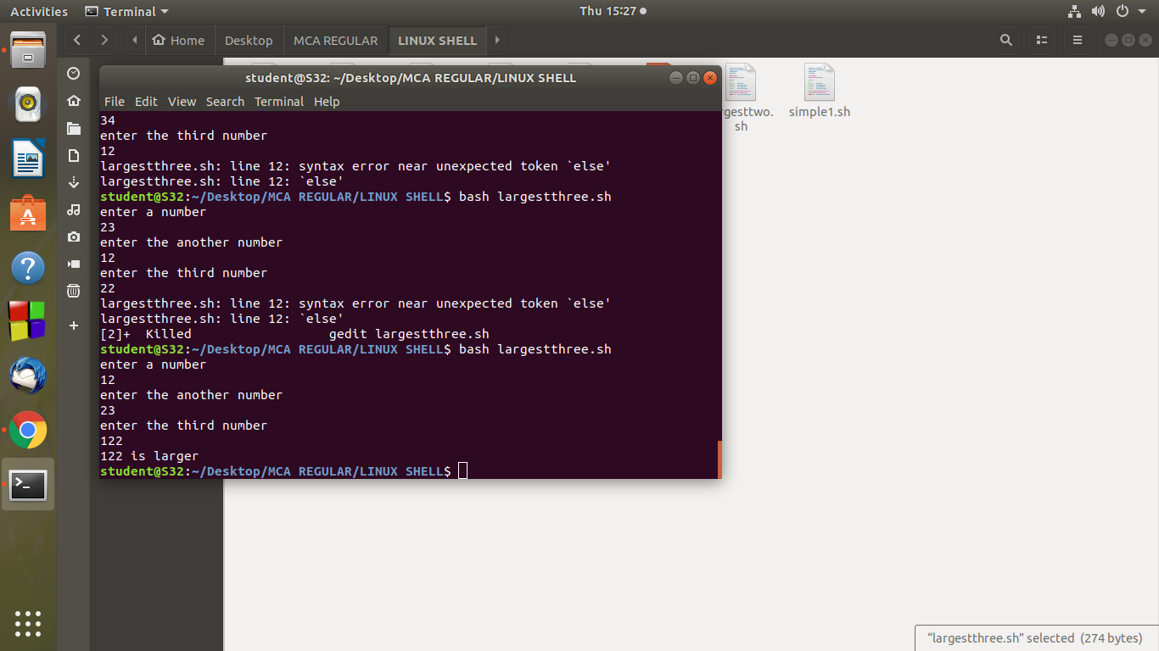
program no-5

Aim:check whether a given number is odd or even.
